Katherine Pre Employment Program
Katherine has nine more job-ready hospitality workers after a Hospitality Pre Employment Program was run, with the support of the Department of Business.
The program resulted from requests from Katherine based hospitality businesses through the Australian Hotels Association (AHA) to support local employment in the region.
The work-focussed program has been conducted over six weeks by local registered training organisation the International College of Advanced Education and combined classroom based theory with work experience placements at the Katherine County Club and Knotts Crossing Resort.
Participants undertook a mix of accredited and non-accredited training including certification in Responsible Service of Alcohol (RSA), Responsible Service of Gaming (RSG) and customer service.
The program concluded on Wednesday 13 April 2016, with a graduation for participants held at the Knotts Crossing Resort.
Nine students commenced the program and seven completing it, two others secured work while they were undertaking their studies. All participants have either secured employment or have opportunities available to them - a great outcome for all.
Program participants Tamara Rankine and Peta Ross were offered positions after the graduation by the Knott’s Crossing Resort. Tamara had high praise for the quality of teaching.
"Our trainer Peter McMillan was just wonderful and he made learning fun,” she said.
General Manager of the Katherine Country Club, Frank Dalton said the program had been an excellent example of cooperation.
"It was a true reflection of the Katherine spirit that government, local business and the International College of Advanced Education as the training provider could work together so well in order to provide career opportunities within Katherine.”
Upon graduation, students were congratulated and issued with their certificates and a unique hospitality pack comprising various tools of the trade.
International College of Advance Education Chief Executive, Sean Mahoney, praised the Department of Business for their support of local businesses through provision of high quality, employment based training.
"This type of training program, when delivered in concert with local employers and government, provides real employment outcomes for both Territorians and industry.
“The support of the Territory Government is vital and very welcome in providing solutions for businesses seeking skilled locals for their businesses.
“We are delighted with the outcomes of this program for the participants, employers and the hospitality industry in Katherine" he said.
Figure 1 L to R Sean Mahoney (ICAE - CEO) with program participant Peta Ross and the Hon Willem Westra Van Holthe MLA

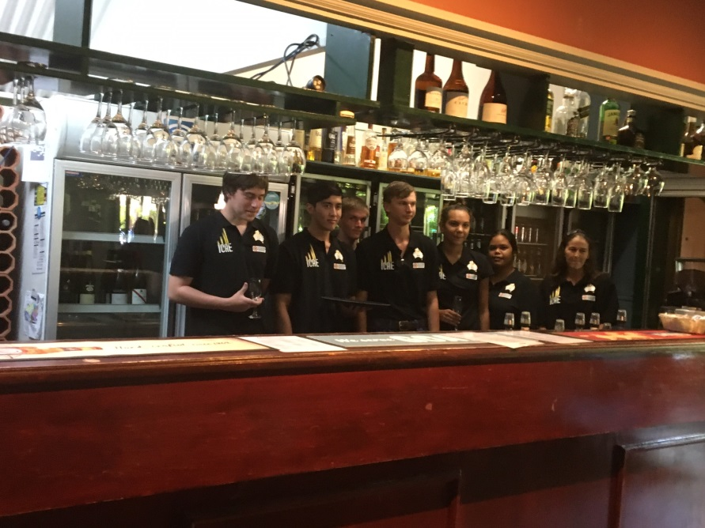
Figure 2 Katherine Hospitality Program participants from L to R Tyrone Dittman, Joshua Bell, Sam Barrington, Tristan Jack, Peta Ross, Tamara Rankin, Lee Kirby

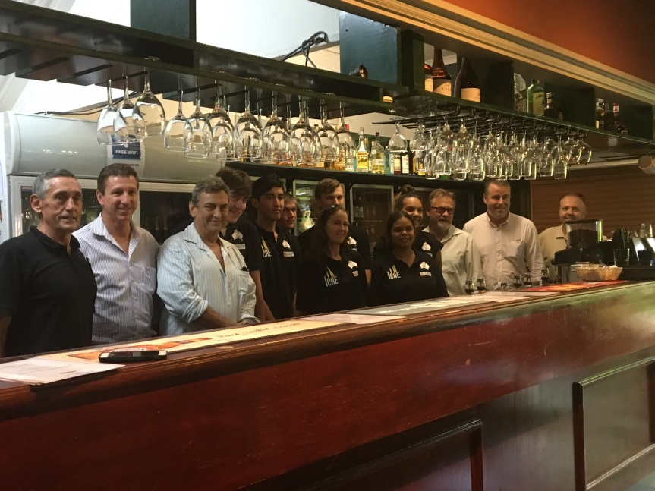
Figure 3 L to R Peter McMillan (ICAE Trainer) the Hon Willem Westra van Holthe MLA, Frank Dalton (Katherine Country Club), Tyrone Dittman, Joshua Bell, Sam Barrinton (at rear) Lee Kirby, Tristan Jack (at rear), Tamara Rankin, Peta Ross, Chris Capper (AHA), Sean Mahoney (ICAE), Jasper Petri-Stuart (Knotts Crossing Resort)

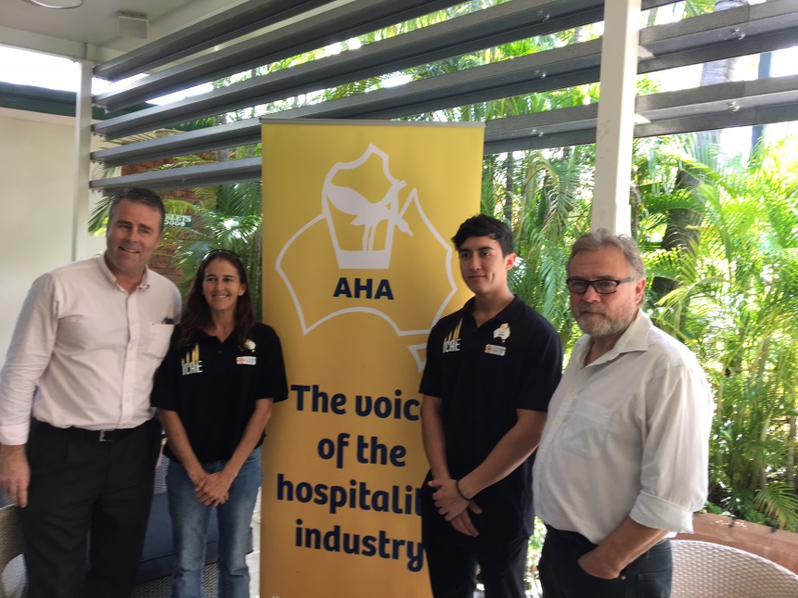
Figure 4 L to R Sean Mahoney (ICAE) with program participants Lee Kirby, Joshua Bell and Chris Capper (AHA)

